Scenario brief: AI lead scoring lifecycle management in Dynamics 365

# Step 1: Analyze performance and feedback

This document provides the necessary background for your graded activity: "Managing the lifecycle of an AI-powered feature in Dynamics 365." It outlines the product context, the specific AI feature you'll be working with, and the challenge you need to address as an Associate Product Manager.

**The context Microsoft Dynamics 365 sales**

Microsoft Dynamics 365 Sales is a comprehensive, cloud-based Customer Relationship Management (CRM) application used by businesses globally – from small companies to large enterprises. It serves as a central hub for sales teams within these organizations to manage customer interactions, track leads and opportunities, streamline sales workflows, and gain insights into their performance. Adding intelligent, AI-powered features is key to maintaining Dynamics 365 Sales as a competitive leader in the B2B software market. Users expect powerful functionality combined with the trust, security, and compliance standards associated with Microsoft enterprise products.

**The feature AI-Powered Lead Scoring**

Recently launched within Dynamics 365 Sales, the AI-powered Lead Scoring feature analyzes various data points associated with sales leads (e.g., lead source, engagement history, firmographic data). It’s designed to generate a score predicting the likelihood of that lead converting into a paying customer.

* **Intended customer benefit:** The primary goal is to help the sales teams using Dynamics 365 Sales work more efficiently by focusing their time and resources on the leads most likely to convert. This improves their productivity and potential revenue generation.
* **Responsible AI:** While driving efficiency, the feature was designed with Microsoft's responsible AI principles in mind. Ongoing attention must be paid to the model's accuracy, potential biases in scoring across different types of leads or customer segments, and the transparency of the scores to the end-users (the sales professionals at customer companies).

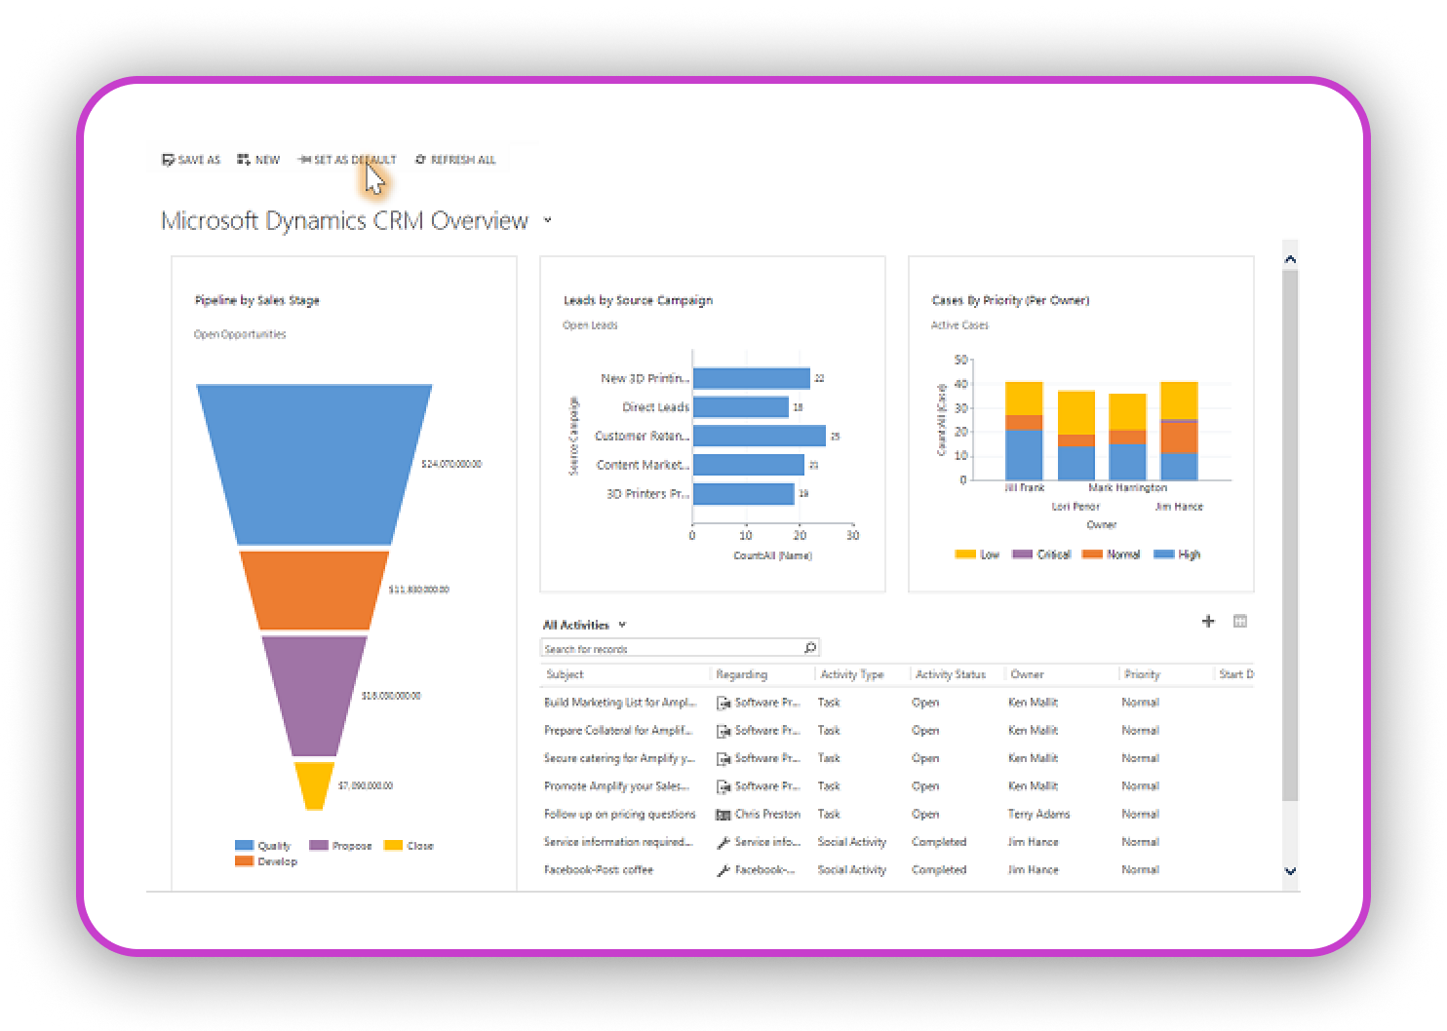**Alt text:** A screenshot of Microsoft Dynamics CRM Overview dashboard is shown with a navigation menu open on the left, highlighting the Microsoft Dynamics CRM Overview. The dashboard displays several charts and data visualizations, including "Leads by Source Campaign" (a horizontal bar chart), "Cases by Priority (Per Owner)" (a stacked bar chart), and an "Opportunity Pipeline" funnel chart at the bottom left.

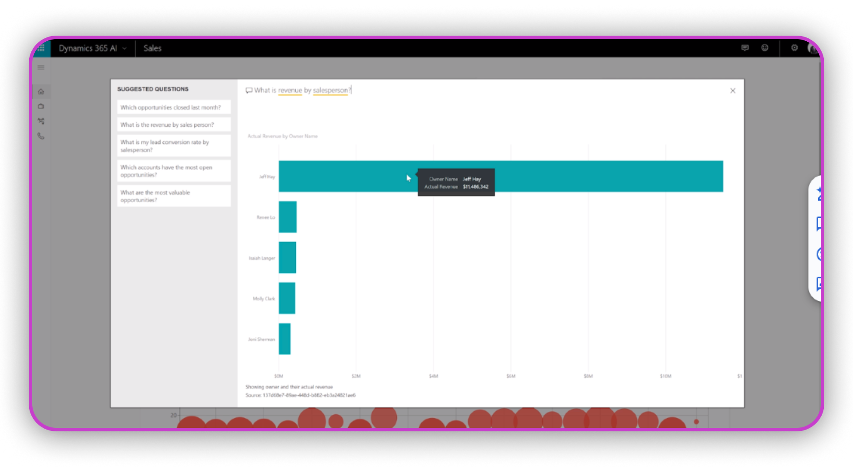**Alt text:** A Power BI interface displays a horizontal bar chart titled "What is revenue by Salesperson?" showing actual revenue by owner name. "Jeff Hay" has the highest revenue. To the left, a "Suggested Questions" pane lists options like "Which opportunities have closed last week?" A tooltip is visible showing the owner’s name and actual revenue.

**The challenge, your role**

The Lead Scoring feature is now live and being used by Dynamics 365 Sales customers. Initial performance data and user feedback are becoming available. As the Associate Product Manager responsible for this feature's post-launch lifecycle, you need to develop an integrated management plan. Your manager has tasked you with outlining your strategy for:

1. **Monitoring performance:** How will you track the AI model's effectiveness and identify potential issues?
2. **Iterative improvements:** How will you handle updates, address identified problems (like accuracy issues or user confusion), and test changes?
3. **Ethical oversight:** How will you continue to monitor for and mitigate potential bias or fairness concerns?
4. **Feedback integration:** How will you collect and act upon user feedback to guide the feature's evolution?
5. **Communication:** How will you communicate changes and updates to the users?

**Key considerations for your plan**

As you develop your plan, consider that initial data might show metrics like overall prediction accuracy, user adoption rates of the feature, and maybe some variance in performance across different lead sources or industries. Early user feedback might include comments on the perceived usefulness of the scores, questions about *why* a lead received a certain score (transparency), and possibly reports of scores seeming incorrect in specific situations. Your plan needs to address how you'll investigate and respond to these kinds of real-world signals.